Red hat Satellite server

**Standard Operating Procedure (SOP) Document**

Submitted To

By

Integrated Services Transition

Wipro Technologies

November 2025

Revision History

|  |  |  |  |  |  |
| --- | --- | --- | --- | --- | --- |
| Version # | Date of Revision | Description | Author | Reviewed By | Approved By |
| v0.1 | DD/MMM/YYYY | Initial Draft | Rambabu S | Aditya Marella | Jitendra |
| v0.2 | DD/MMM/YYYY | TSG Review | Author Name | TSG Name | TSG Name |
| V1.0 | DD/MMM/YYYY | Customer Review | Author Name | Customer SME Name | Customer SME Name |

Statement of Confidentiality

The information contained in this document is confidential.

Copyright Acknowledgment

Any registered names, trademarks and logos used in this manual remain the property of the owning respective companies or organizations concerned.

Disclaimer

The documentation is prepared based on the specifications and requirements specified or disclosed to Wipro Technologies by Entrust and is tailored for the requirements and environment of Entrust.

This document provides information and user instructions for Entrust. These functional descriptions have an underlying assumption that Entrust internal procedures will have defined and implemented levels of user authorization appropriate to the various functions involved to minimize the risk of accidental or intentional misuse of those systems. While we strive to capture information that is accurate, there could be a few inaccuracies or typographical errors, and will be corrected in future revisions. Changes are periodically added to the information herein: these changes will be incorporated in subsequent version(s) of the documentation. Entrust may make improvements and / or changes in the documentation.

Warranty

This documentation is provided “as-is“, without warranty of any kind, either expressed, implied or statutory, including but not limited to the implied warranties of merchantability or fitness for a particular purpose.

Table of Contents

1 Introduction 8

1.1 Purpose 8

1.2 Scope of Service 8

1.3 Prerequisites 8

2 Standard Operating Procedure 9

3 Appendix – Glossary of Terms 10

List of Tables

Table 3: Table Description 8

Table 58: Glossary 9

List of Figures

Figure 4: Screenshot Description 8

1. Purpose

The purpose of the document is to register and extend the Red hat satellite.

* 1. Scope of Service/BUs

Red Hat Satellite is a system management solution that enables users to deploy, configure, and maintain systems across cloud environments.

* 1. Prerequisites

While most Linux systems are registered to Satellite during the bootstrap process, some workloads require post-deployment registration.

1. Standard Operating Procedure

Table 1: Table Description

|  |  |  |
| --- | --- | --- |
| Sr. No | Server Name | Server Function |
| 01 |  |  |
| 02 |  |  |
| 03 |  |  |

Figure 1: Screenshot Description

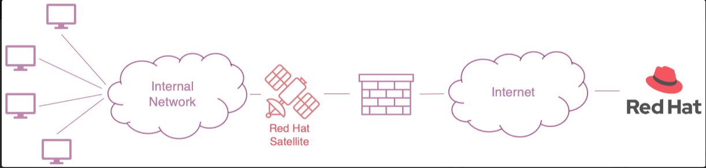

**Satellite Registration:**

sudo bash -c "$(curl -fsSL https://binary.entrust.com:8443/artifactory/infra-tools/devReg.sh)"

**Satellite Extended Update Support (EUS):**

1. subscription-manage repos --disable=*eus*

**Note:** EUS repos are used on minor versions. All the latest updates are through non-EUS, App Stream, and Base OS repos.

**To set minor version and enable EUS, use the following commands:**

1. subscription-manager release --list
2. subscription-manager release --set=8.9(e.g.)
3. subscription-manager release --show
4. subscription-manage repos --enable=*eus* (or specific eus repos)

**Bootstrap (Linux):**

When an Entrust IT (EIT) supported Linux [template](https://entrustdatacardcorp.sharepoint.com/sites/ECC/SitePages/ECC-Templates.aspx) is deployed, the Linux bootstrap (script) is triggered by a *system*d service when the VM is initially powered on.

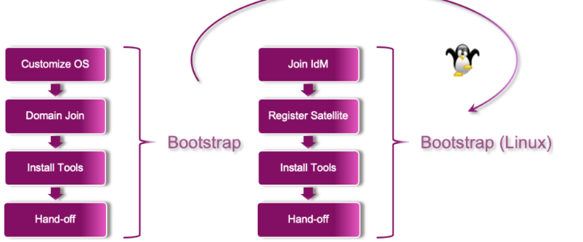

The Linux bootstrap process includes the following steps:

**Step 1**: Reset network configuration

**Step 2**: Register system to (on-prem) Satellite

**Step 3**: Attach release-based subscriptions

**Step 4**: Install IPA client (identity and authentication)

**Step 5**: Enrol in IdM realm (idm.dev.entrust.com)

**Step 6**: Add patch management (ssh) key

**Step 7**: Install Summit AI (asset management)

**Step 8**: Install Salt minion (config management)

**Step 9**: Onboard to Defender (endpoint security)

The command below in the right pane view triggers the Linux development bootstrap process.

sudo bash -c "$(curl -fsSL https://binary.entrust.com:8443/artifactory/infra-tools/devbootstrap.sh)"

1. Appendix – Glossary of Terms

Table 58: Glossary

| Abbreviation | Description |
| --- | --- |
| PCS | Private Cloud Services |
| DC | Datacenter |
| DR | Disaster Recovery |
| EIS | Enterprise information Solutions |
| HA | High Availability |
| LUN | Logical Unit Number |
| OS | Operating System |
| UCS | Unified Computing System |
| RAID | Redundant Array Inexpensive Disks |
| SAN | Storage Area Network |
| vSAN | Virtual SAN |
| vCenter | Virtual Center Server |
| vCPU | Virtual Processor |
| VM | Virtual Machine |
| vNIC | Virtual Network Card |
| VMNIC | ESXi Host Physical Network Card |
| vRAM | Virtual Memory |
| NIC | Physical Network Interface Card |
| CPU | Central Processing Unit |
| HBA | Host Bus Adapter |
| WWN | Worldwide Name |
| PROD | Production |
| AD | Active Directory |
| SRM | Site Recovery Manager |
| CMDB | Configuration management database |
| DMZ | De-Militarized Zone |
| DNS | Domain name server |
| EUC | End User Computing |
| FQDN | Fully qualified domain name |
| HTTP | Hyper-text transfer protocol |
| HTTPS | Hyper-text transfer protocol secure |
| IM | Instant Messaging |
| KAP | Knowledge Acquisition Phase |
| KPI | Key Performance Indicator |
| KT | Knowledge Transition |
| LAN/ WAN | Local Area Network/Wide Area Network |
| NTP | Network Threat Protection |
| SLA | Service Level Agreements |
| SMTD | System Maintenance & Technical Document |
| SNMP | Simple network monitoring protocol |
| SOW | Statement of Work |
| vSS | Virtual Standard Switch |
| SSL | Secure Socket Layer |
| SSO | Single Sign On |
| vDS | Virtual Distributed Switch |
| TCP | Transmission control protocol |
| vROPs | vRealize Operations Manager |
| RDC | Regional Data Center |
| VR | vSphere Replication |
| FI`s | Fabric Interconnects |
| FEX | Fabric Extenders |
| CIMC | Cisco integrated management controller |
| TCP | Transmission control protocol |
| TCP/ IP | Transmission Control Protocol /Internet Protocol |